**Task: Setup a Linux Virtual Machine with Docker,**

**Minikube, SSH Login, and Password Authentication**

**(with Linux host PC option)**

**Description:**

In this task I learned how to set up a Linux virtual machine (VM) on my Windows PC using virtualization software called Oracle VM VirtualBox. This VM provided me with Linux environment for running apps like Docker, Minikube clusters etc., I also enabled SSH login with password authentication for remote management which i can also control via my Windows pc remotely.  
 **Steps for installing virtualization software and creating VM:**

1. Installing and creating VM (VirtualBox version: 7.0.14)
2. Choosing Linux destribution (my choice: Ubuntu 22.04.3 LTS)
3. Downloading ISO image for Linux
4. Creating new virtual machine
5. Installing Linux distribution and booting new OS.

**Steps for configuring the VM and installing necessary softwares:**

1. Updating Linux with the latest packages and security updates(sudo, vscode)
2. Installing and configuring SSH server on VM and enabling remote access.
3. Enabled password authetication for SSH login.
4. Installing Docker by following docker documunetation.
5. Verifying docker installation by running simple container saying Hello World.
6. Installing Minikube by following official documentation.
7. Started Minikube cluster on VM.

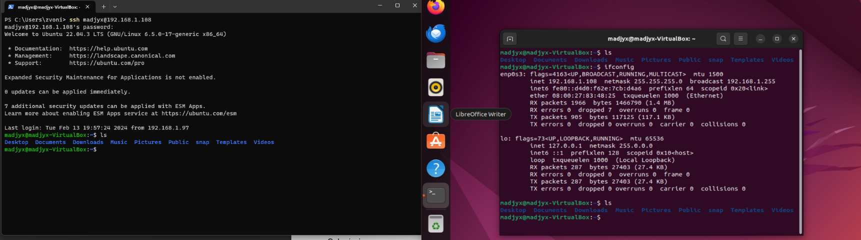**Proofs for SSH login steps:**

SSH LOGIN

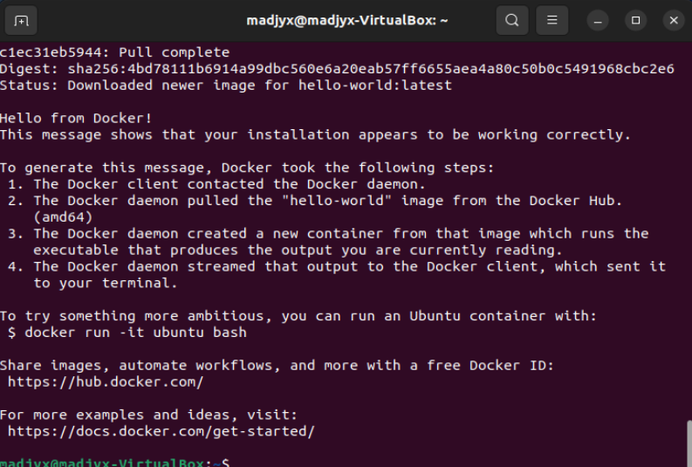

HELLO WORLD Docker

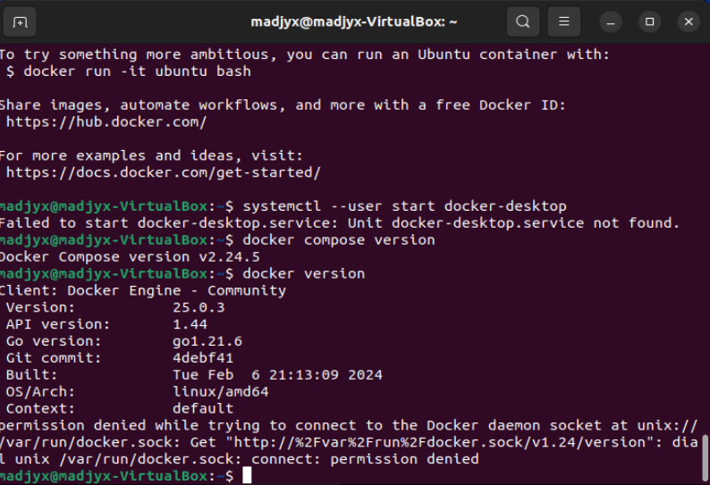

Succesfully installed docker and version of docker

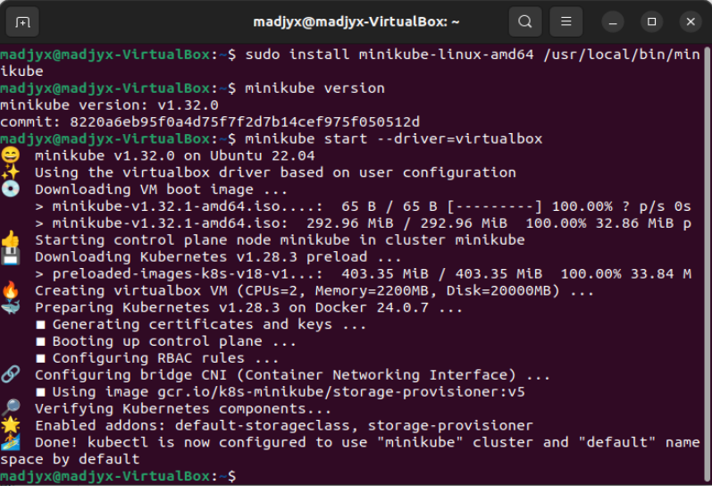

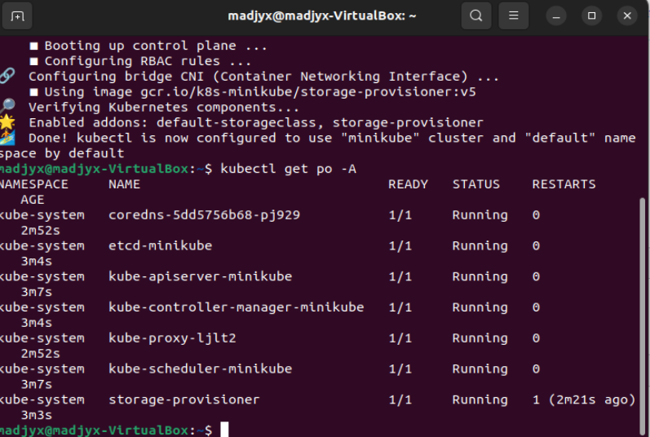

Minikube and kubernetes configs

**Steps for container deployment:**

1. I have selected a simple container image from Docker Hub (Nginx)
2. Pushed and pulled all images on VM.
3. Running all containers using Docker.

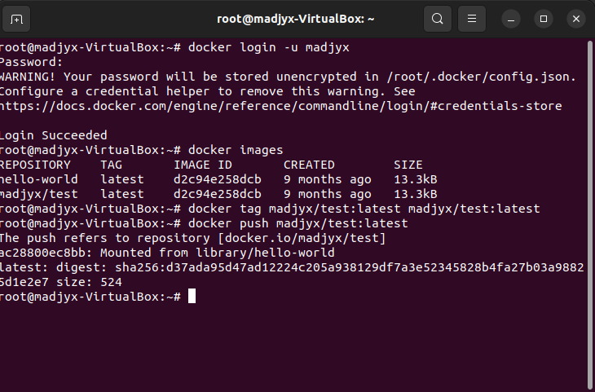

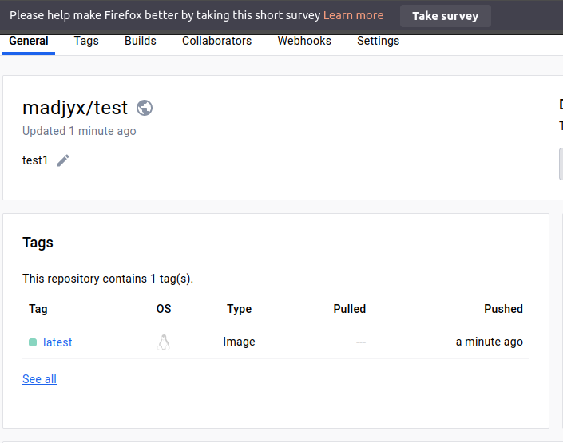

First login and first push with commands.

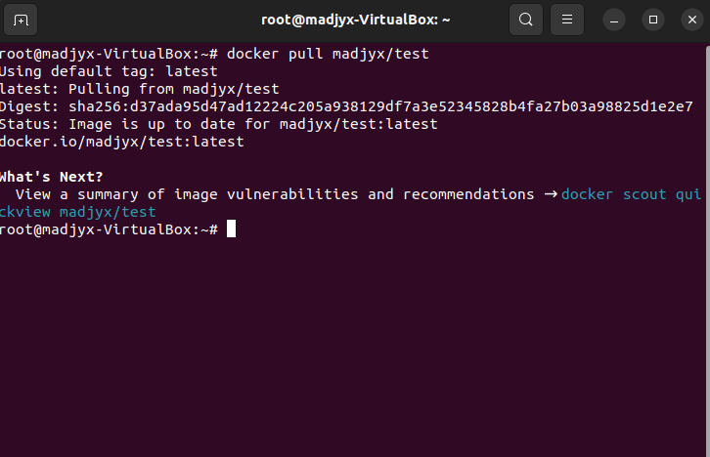

First pull image.

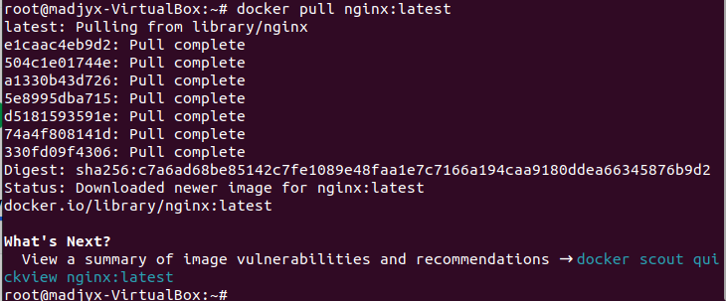  
Pulling Nginx image.

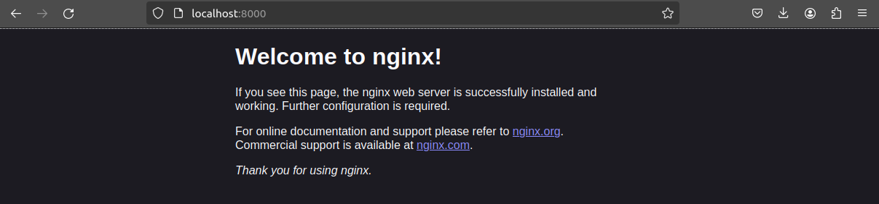  
Running the container Nginx on localhost.

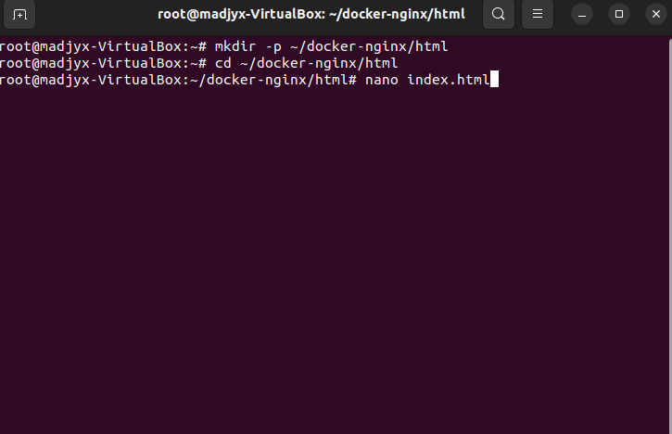

Editing index.html and saving changes.

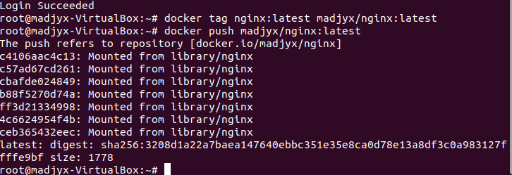

Pushing and pulling edited html.

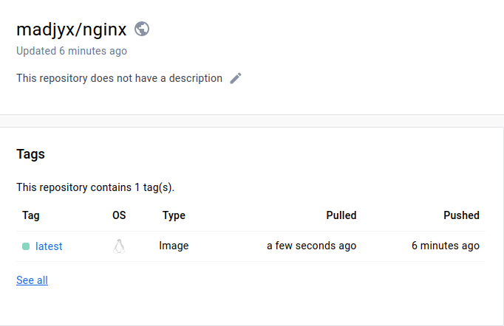  
Success!

**Conclusion:** In this task I learned how to install and configure VM. Installing Linux on VM.  
Using and configuring key word for Kernel. Configuring SSH Login and password authentication. How to install and configure Docker by following official documentation for Linux. Learned commands and functions used for container executions and outputs.  
  
**Terminal commands used:** mkdir, touch, pwd, uname, echo, cd, grem, rm, ls, grep, sudo, ps, hostname, nano etc.

**Docker commands used:** docker start container-name-or-id, docker pull, docker push, sudo apt install gnome-terminal, systemctl --user start docker-desktop etc.  
  
Zvonimir Mađarac.